Homework assignment #1 for CSC 352/452,

Due time/date 5:30 PM, 4/8/202, Wednesday

(each question 10 points, total 100)

These will be routine for this spring quarter.

Students in CSC352 and CSC452 share the same questions to avoid confusing. When grading, the instructor will be lenient to students in CSC352 as requested by university policy.

Unless special noted, each week there will be a homework assignment posted on D2L on Wednesday. Due date/time will be 5:30 pm next Wednesday, just like we still had the live section. All submitted programs must pass the compilation. Unless there are special comments, if the program is not runnable, it will not get partial credits. Later submitted homework will lose 20% credits per day delayed; after two days, submission on D2L will be closed.

Before you work on the hw #1, you need to finish the preparatory work. Actually, that is an important part of hw #1.

Set up your work environment, either use the SQL*Developer on CDM lab machine, or on your own machine, connect to DePaul teaching Oracle server. The instructions for setting up SQL developer are posted in the folder “Content -> Optional Files”.

It is required to build the Emp-DEPT, and Oracle HR sample (seven) tables, by running scripts provided on D2L site, folder “Content -> Script for creating tables”. Be careful to set up the “path”. From where you store the script file, you can see the “path” on the top bar, screen capture below shows what on my computer.

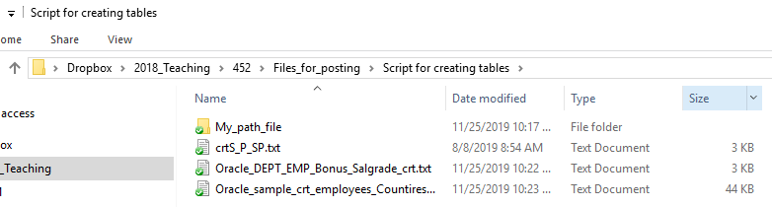

If you left click the path bar, it will change to string that you can copy and replace the “path”.

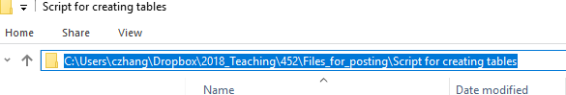

What you need to submit:

one text file (such as hw1_xx.txt) to Submissions section, hw#1 in D2L. Only text format file please. You may use notepad.

What you need to include in the file:

the SQL, PL/SQL codes. No need to include the output, no need to repeat the question itself.

This homework assignment will serve the purposes to let you warm up in SQL coding, build and explore the sample tables. I have included some hints for some questions at the end of this file, in case someone does not have the right background in SQL yet.

1. Display all the employee’s name, salary and their department name for those who do not get commission, and salary less than 2,000. (using table EMP and DEPT).
2. Display the employees’ names, their salaries, their manager’s name and their manager’s salary for those who work in department no. 20. (using EMP table).
3. Using table Employees and Departments for this question.

List the department ID, department name and the number (how many) of employees that belong to that department.

1. Using table Employees and Departments for this question.

List the department ID, department name that have no employee now.

1. List the last name, first name, and his/her manager’s last name for those employee(s) who is(are) not assigned to a department yet.
2. List the amount of highest income (salary plus commission_pct * salary), lowest income for each department (group by Department_ID).
3. List all the employee ID, last names, first names and department id for those have same last name in this company (or say in the Employees table).
4. List how many phone numbers are for international in this company?

assuming that the phone numbers start with “011” are for international

1. List the table names you have created (that is about system catalog, use either tab, or user_tables).

1. Write an anonymous PL/SQL block. In the block, declare a variable named emp_name, data type as varchar2 (15). In the executable section, retrieve the ename of employee with id of 7839, the syntax will be

“SELECT ename INTO emp_name from emp where empno = 7839; ”

Then use the DBMS_OUTPUT.PUT_LINE (' ' ) command to print out the result.

**Some Hints**.

Q1. you need to join the table EMP and DEPT, WHERE emp.deptno = dept.deptno and ...

Q2. Join the emp table with itself, as the manager’s info are in the column “MGR”.

Q3. Using “Group by” and function COUNT. Information about which employee works for which department are in the employee table; department name is listed only in departments table. Notice that the select list must match the group by. That means, if you have

“SELECT d.Department_ID, department_name, ... ” as select list, then you need

“ Group by d.DEPARTMENT_ID, department_name”

Q4. Sub query might help, such as

where department_id not in (

select distinct ...

Q5. Manager information are in the same table of Employees, be careful that the department_id not assigned, it means the value of department_id is null.

Q6. Be alert with the null value for commision_pct.

Using (NVL (commission_PCT, 0) ) instead of simple commision_pct.

you may need to use the function: MAX( (salary + salary * NVL (commission_PCT, 0) ))

and the MIN ( ).

Q7. Similar as Q4, a subquery may help:

where last_name in

(select last_name from employees

group by last_name

having count(*) > 1)

Q8. You may need the function substr (phone_number, 1, 3)

Q9. desc user_tables will display the columns define in that table.

COLUMN tname format A18 or

COLUMN table_name format A18

might help to format the output.